SAP Application Development

(S/4 HANA)

SAPUI5

Motivation  This chapter will show you how to develop SAPUI5 applications and demonstrate how the Model-View-Controller (MVC) concept works. Therefore, you will learn how to implement SAPUI5 applications using XML and JavaScript, and how they can be deployed to the SAP backend. Furthermore, you will work with different view elements. | Prerequisites  Before starting this exercise, you should be familiar with the Eclipse IDE. Furthermore, it is recommended that you have completed the HTML5, CSS & JavaScript chapter.
Content  This chapter explains the development process of an SAPUI5 application. First, it will be explained how you create an SAPUI5 project. Second, an initial view and its logic will be implemented. Afterwards, a second view is created, which is linked to the first view and shows data values which were passed from the initial view. Then, the application will be deployed to the SAP backend. Finally, it will be explained how you use a debugger to retrace the program code of SAPUI5 applications. | Lecture notes  If you skipped the previous chapters on ABAP programming, your students may need to enter a developer key when they deploy their applications to the SAP backend. Please consult the lecture notes for further assistance on this topic. Furthermore, students should use their individual three-digit number when they deploy their applications to the SAP backend. In this exercise, these are displayed as ### and have to be replaced by the students’ individual numbers. In addition please replace $$ with your two-digit institution id.

- Product: All

- Level: Advanced

- Focus: Programming

- Version: 2.0

- Author: UCC Technical University of Munich

Task 1: Create an SAPUI5 application project
Short description: Creating an SAPUI5 application project with an initial view and controller

Start Eclipse. In the context menu of the Project Explorer, choose New->Other->SAPUI5 Application Development->Application Project. Click Next.

Create SAPUI5 application
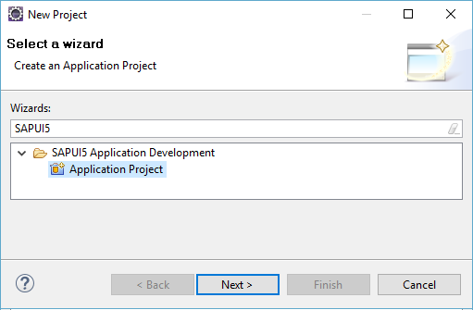

Give your project the name MVC_App (no need to add your three-digit number at this point). Choose sap.m as library, check Create an Initial View, and click Next.

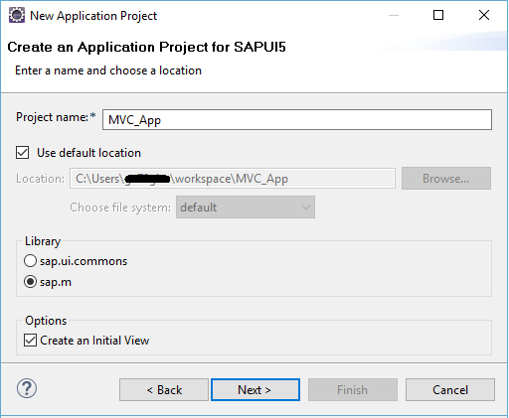

On the next page, you have to define the properties for your initial view. Enter the name main, and select to develop the view using XML. Click on Finish to create your project. If you are asked if you want to change your perspective, click Yes (the recommended perspective is JAVA EE).

Task 2: Modularize your application
Short description: Make your application fit for reuse in other applications and the Fiori launchpad.
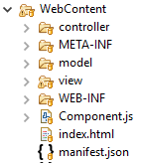
Modularizing SAPUI5-Projects enables us to reuse certain parts of an application or work on them independently. For this purpose, the concept of components comes in handy.

To turn your application into a component, recreate the folder structure on the right: inside of the WebContent folder create the folders model, view and controller, move your main.view.xml and main.controller.js into the corresponding folder, and delete the folder mvc_app (rename Main to main if necessary).

Create a file Component.js. We will store the information to start our application in it. Also create the file manifest.json. Eclipse will highlight the file as erroneous – ignore that for now. In this file we will store metadata and routing information.
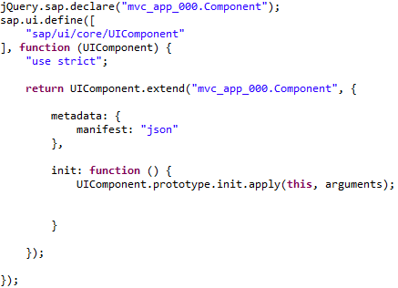
Write the code on the left into the Component.js file. The sap.ui.define-statement enables us to implement the asynchronous module definition. In asynchronous module definition, files are only loaded when they are needed and not all at once, improving the overall performance. The first parameter in the statement is an array, containing all the dependencies required. The second parameter is a function, returning the respective resource, that has been defined. We extend the UIComponent-Class, passing the name of our module (namespace + .Component). In this case we choose the namespace mvc_app which is further specified in index.html. The first line declares the application as a component so that it can be integrated into the Fiori Launchpad. Do not forget to replace 000 with your own number.

Since we transferred our application logic into a component, we have to edit the index.html file. Its solely purpose will be to call the component, further details, e.g. which resources have to be loaded, are from now on handled by the Component.js file.

Now open the index.html file. Delete the division inside of the body and give the id “content” to the body itself. Rewrite the app instantiation as shown below. Also change the script definition (the upper script-tag). Do not forget to replace 000 with your own number.

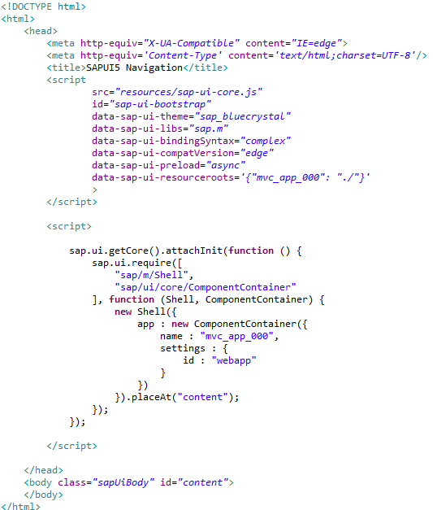
Since we are going to create multiple controllers, which will share some basic functionalities, we can make use of the statements .define and .extend because they offer structure similar to inheritance in object-oriented programming. In our case the javascript-file “baseController.js” will contain those basic functions and can be extended by the other controllers. Create it in the controller folder. Do not forget to replace 000 with your own number.
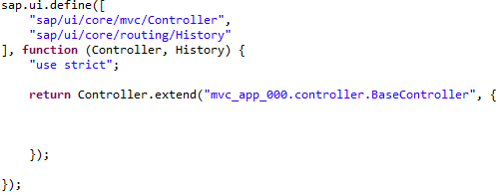

In this last step, we want to apply the asynchronous module definition to our main.controller as well. Therefore, change the code of the controller accordingly and do not forget to replace 000 with your own number.
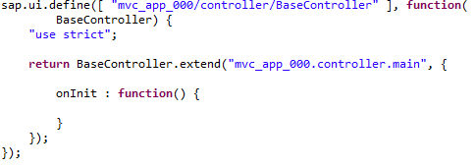

Adapt the controller name in the main view:

Task 3: Implement the initial view
Short description: Inspecting the main view and creating the layout of it

Open the main.view.xml file that you’ve moved into the view folder and choose the Source tab, which is located at the bottom of the main window if you do not see the source code per default. There, we want to define a central tab view, which is shown when the application is started. In this exercise, we want to create an application which shows Arrival and Departure flights in two different tabs. For this, first change the title of the view to Flight Monitor:

Implement initial view
Next, we want to create two tabs, which will be called Arrival and Departure. In the Arrival tab, we want to show a table which contains static flight data. The Departure tab will stay initially empty, and will only contain a small text line which announces that this feature will be implemented soon (actually, the content of the Departure tab will be part of the challenge at the end of this exercise). Therefore, to create the mentioned functionalities, first add the TabBar to your code (content section of the main view):

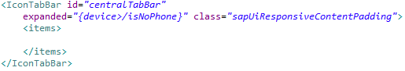

Define the two tabs inside if the TabFilter. Do not forget to save your file afterwards.

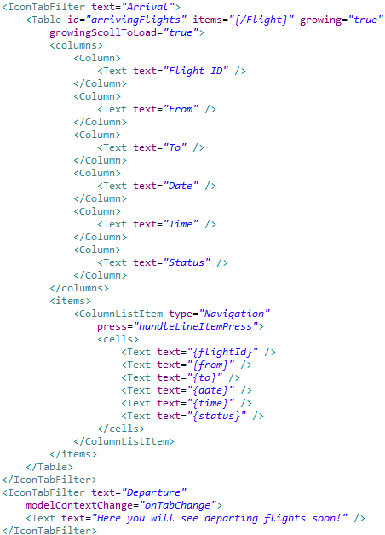
main.view.xml: <content> section

As you can see, the Arrival tab contains a table definition, which links to Flight items.

Task 4: Implement routing
Short description: Add multiple views and navigate between them, using routing

The developed application is not runnable yet. Routing implementation is necessary for that. This enables us to navigate within a single-page application and bookmark pages or applications-states by adding a hash followed by a pattern at the end of the URL (url#/pattern).
To implement routing, we have to make some minor adjustments to the files we created so far. First, initialize a router by adding to the init-function inside of Component.js.

Second, we need a few more views to make use of the router. We will demonstrate basic routing with a home-screen from which we can navigate to our main view. Create the view called “enter”. Do not forget to replace 000 with your own number.
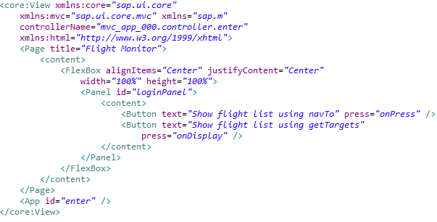

and the respective controller.

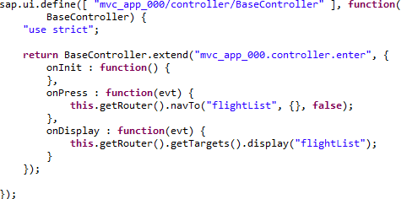
In the code you already come across the two ways of triggering a routing process. In the first case, using .navTo you specify a target, data you want to transmit between the two views as well as a Boolean, indicating whether the current view should be excluded from the router-history. The .display function calls the view specified by the target, but won’t add the according hash to the URL.
To navigate with the router history and to use the function getRouter() we have to implement two functions in our baseController. The required dependency has already been declared:

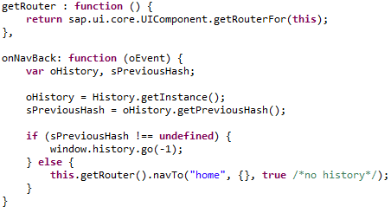
Now we are going to define the routes. Go to manifest.json and add the parenthesis {} to overcome the error. Save the file. Add the object sap.app between the parenthesis, replacing the ### in the id with your own number:
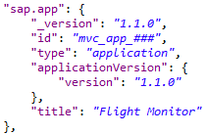
This entry defines the parameters that are necessary to register the app into the Fiori Launchpad. The next entry configures the root view, the json model (will be created in the next task), and the routing, replacing the 000 in the id with your own number:
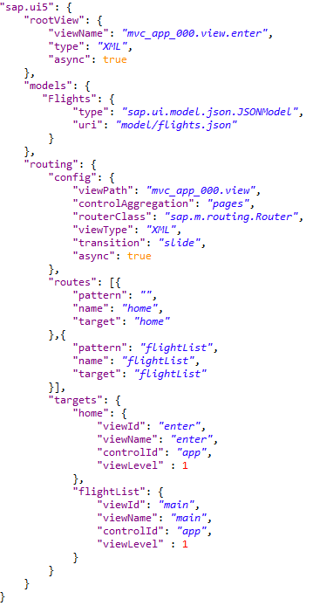
Notice the way routes and their targets are declared. Depending on the URL we can now directly access our main-view (#/flightList) or our enter-view (no hash after the URL). The root view that will be loaded when the user opens the application is the enter view. The control id that the views are embedded into is located in the App view. Create this app.view and the respective controller as seen below. Do not forget to replace 000 with your own number.

App.view.xml
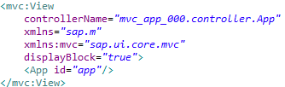
App.controller.js
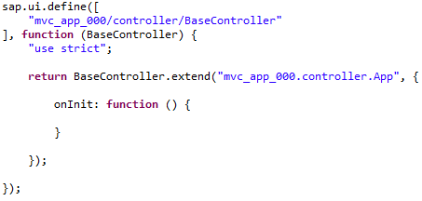
Now that the app containing all the views has been created, it has to be instantiated in the Component.js. Add the following function to your component after the init function:
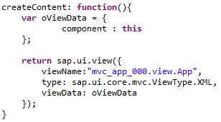

Your WebContent folder structure should now contain the following elements:
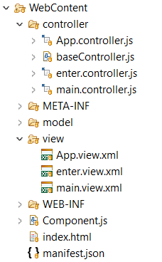
Task 5: Integrate a static data model
Short description: Implement a basic part of the controller component and integrate a static data model provided by a JSON file.

For now, we have referenced the JSON data model multiple times, it is not created just yet. Static JSON model is used since connections to a database will only be handled in the OData Services chapter. Add the file flights.json under the model folder.
Create JSON data file
Your file opens. Please add the following data to the JSON file. Please pay attention to the right syntax, since the JSON syntax is very strict.

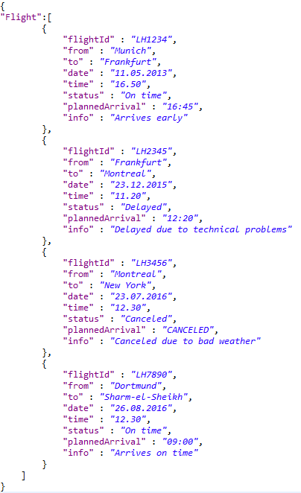

Save your JSON file. Afterwards, open your controller main.controller.js. We want to load the data from the JSON file and show itss contents in our table. For this, we have to modify the onInit function of the controller. Add the following code to the onInit Function (do not forget to replace 000 with your own number):

Create model in controller

Save your controller. Now, we have created a static menu, which consists of two tabs. The first one shows a static table with three entries, while the second one only shows a small text line. The next step is to deploy the application to the SAP backend and to run it.
Task 6: Deploy your application to the SAP backend
Short description: Deploying the application to the SAP backend to make it accessible on the server

Deploy application to SAP backend
To deploy your application to the SAP backend, right-click on your web project MVC_App in the project explorer and choose Team->Share Project. In the next step, select SAPUI5 ABAP Repository as repository type. Afterwards, choose your system connection, and enter User and Password if necessary. Next, define to create a new BSP Application. Enter Name Z_MVC_App_$$_###, a description, and your Package to which you want to assign your application (e.g. Z_$$_###). Click Next.

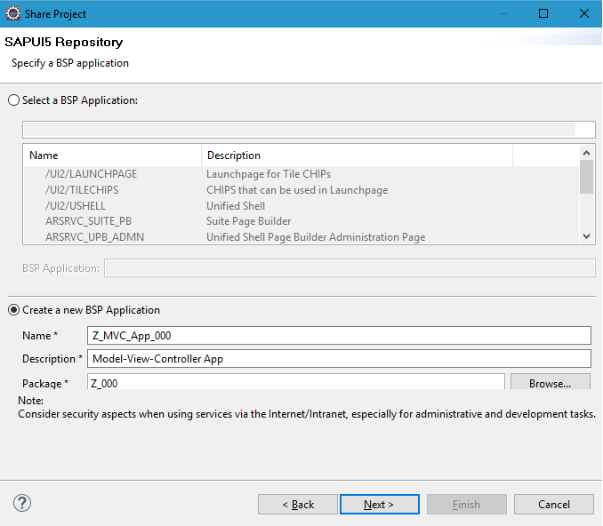

Choose a transport request. Again, you may use your default transport request you used for other exercises. Click on Finish. The application will be deployed to the SAP backend.
Submit repository objects

To test your application, first make sure that all source files were correctly submitted. For this, right-click on your project, and click on Team->Submit. Choose all your files and click on Finish. If submit is already greyed out, everything is fine.

Finally, right-click on your project, and choose Run As->Run on ABAP Server. You may need to login with your username and password. If you test the application for the first time, it may take some time for the window to retrieve all the information from the repository.

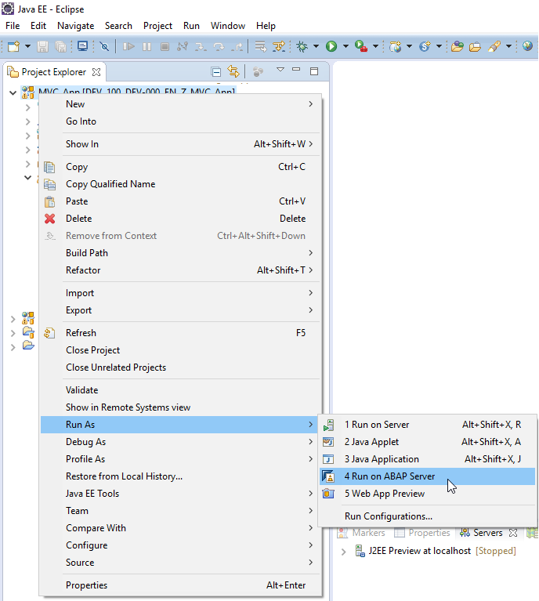
Afterwards, your application will be displayed in the integrated web browser (you can also copy the link to a local web browser and start your application there). If everything worked fine, it should look like this:
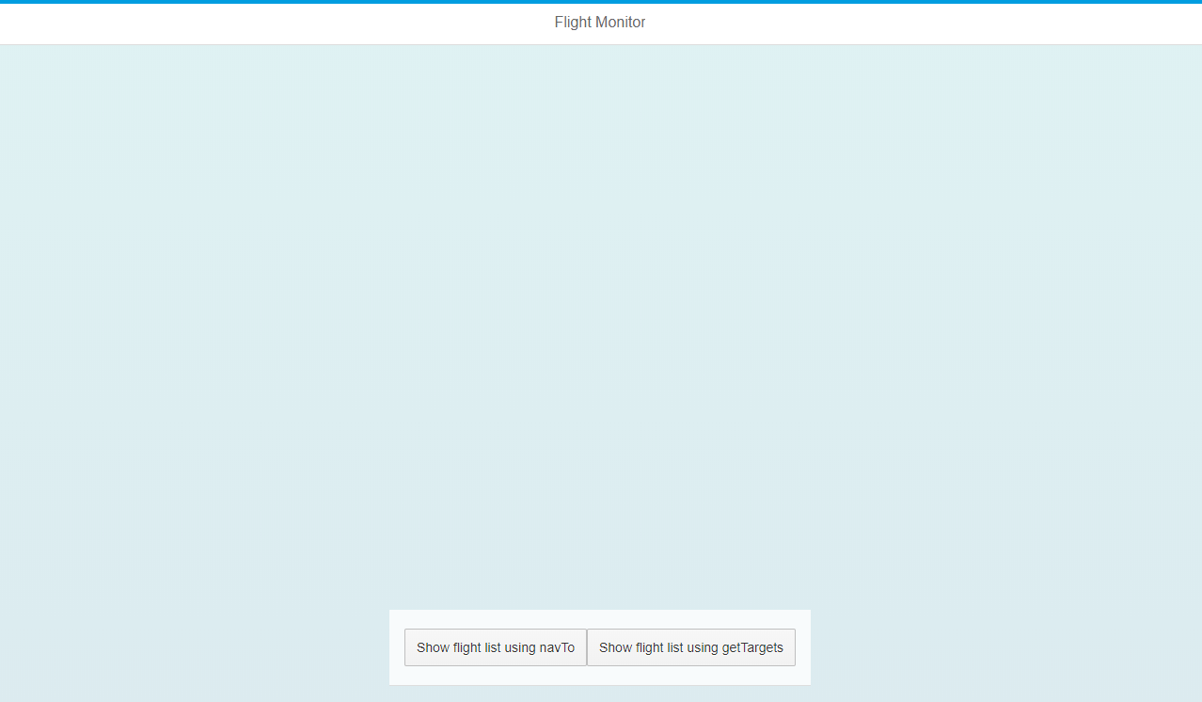

You can try out both ways of navigation, and you’ll see the overview of the arrivals.
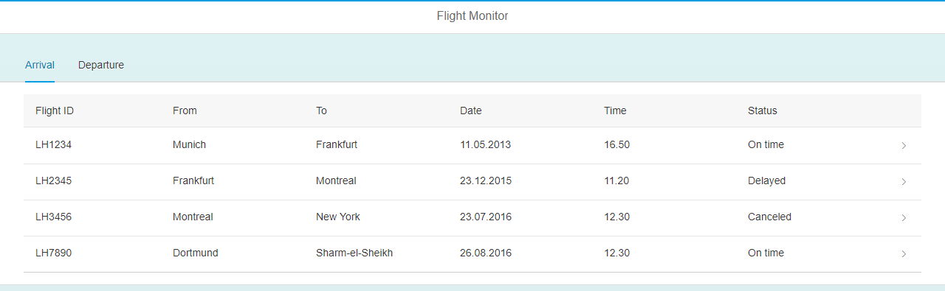
For the departures you will see the placeholder string.
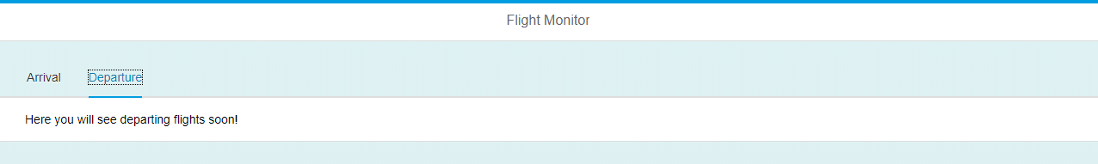
You can notice the different behavior of the “Back” button of your browser depending on which way of navigation you are using.

Task 7: Create a detail view for flight data
Short description: Creating a detail view, which shows detailed information about a selected flight from the table

In order to show detailed flight data after an entry of the flights table was selected, we have to create a new view and a corresponding controller. Name it details.view and implement it as follows (do not forget to replace 000 with your own number):
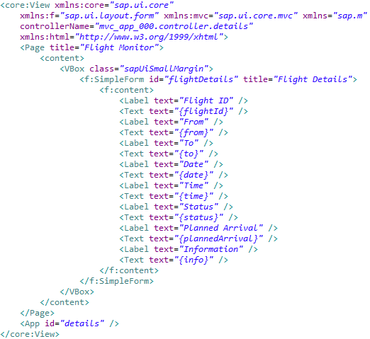
Enter the code below to the details.controller (do not forget to replace 000 with your own number):
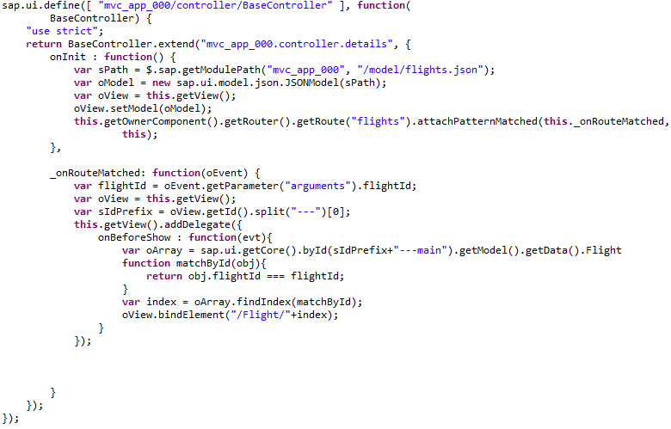
Next, we have to link to the detail page after a user has clicked on a table entry in the main view. You may have probably noticed that in task 2, we assigned the handleLineItemPress function to the press event of the ColumnListItem. We now want to define this function, in which we link to the detail page, and pass the flightID of the object the user has selected. Therefore, please add the following code to the main.controller.js at the end of the file:

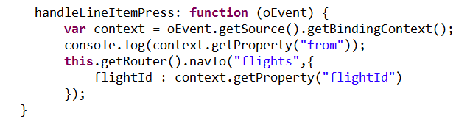

In the last step, we will add the pattern for the details.view. Go to manifest.json and add the route and target:

Handle press event
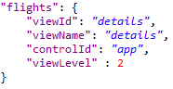
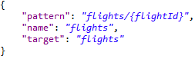

To test your application, submit the changes to the backend (Team->Submit) and rerun it (Run As->Run on ABAP Server).

When you now click on one of the flight objects in Arrival tab, you will be directed to the detail page. The flightID is also part of the URL of the details.view.

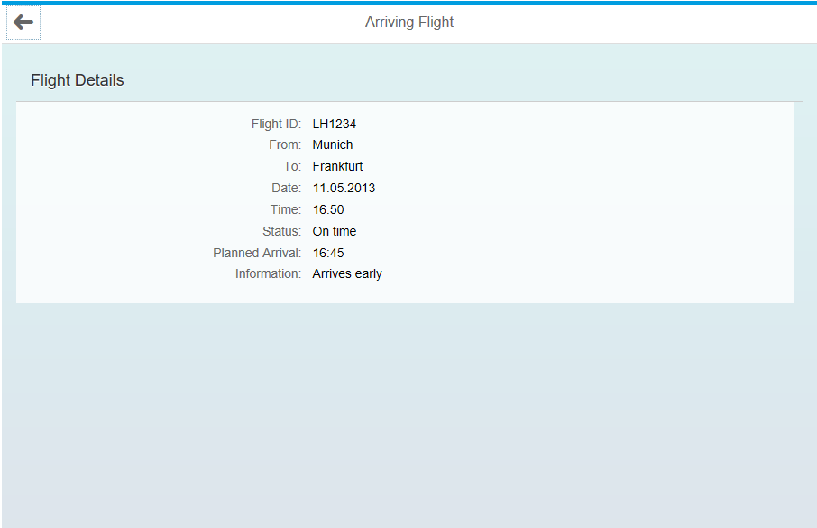

Task 8: Debug your application
Short description: Debugging the application using the integrated developer tools of a web browser (e.g. Google Chrome)

Set breakpoint
Debugging is an important task to find errors in your program and retrace the program execution. In many programming languages, the debugger is integrated in the IDE. However, since JavaScript is only running in a browser together with HTML, you need the help of the browsers’ development tools to debug an application. When you debug your program, in most of the cases, you want to retrace your variables and the value of attributes at a certain point of the program. For this, you can set breakpoints, which stop a program at the respective point. In this exercise, we will demonstrate this by setting a breakpoint after a flight element was clicked in the table, and showing which variables are passed between the views. For this, go to the main controller, and add the following line right BEFORE the var context = evt.getSource().getBinding Context(); statement:

Save the file, and submit your changes to the SAP backend by clicking Team->Submit in the context menu of your project. Now, right-click on your project, and choose Run As->Run on ABAP Server. The integrated browser opens. Please copy the link at the top of the browser window into a local browser, preferably Google Chrome. You may need to login with your username and password. Open the developer tools by clicking on the menu on the upper right and choosing More Tools->Developer Tools.

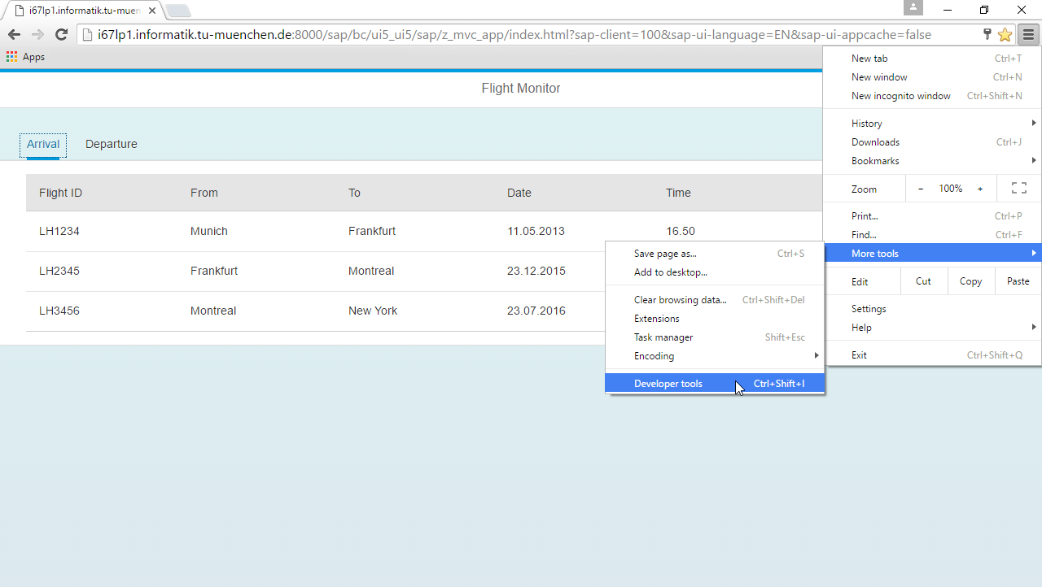

Your application will be shown together with the developer tools. There, a central tool to debug errors is the console. The console shows warnings and system errors in a list. For many errors in your application, the console already shows useful hints on how to solve them. However, in some cases, you have semantic errors which are not shown in the console. For this, it is helpful to know how your variables are changed by your program. In our case, we have already set a breakpoint to debug the variables of our flight table right before the detail page is opened. Therefore, to start the debugger, click on a table entry. The developer tool will jump to the line in the source code where you have set the breakpoint.

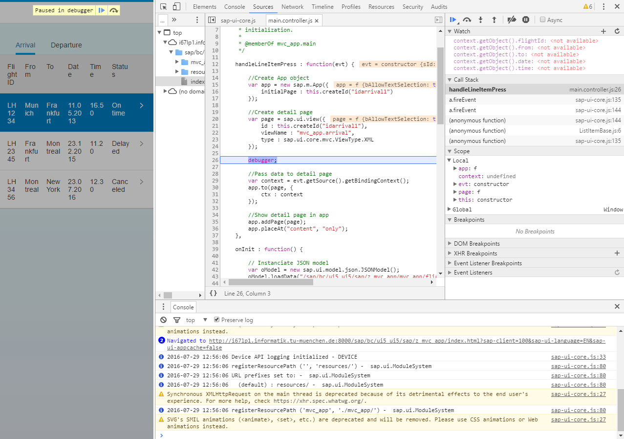

Debug variables
Please search for your variable context a few lines below the debugger statement. Double-click on it to select it, right-click, and choose Add to watch. Your variable will be added to the watch area in the upper right of your developer tools.

Double-click on context in the Watch area, and change the name from context to context.getObject().flightId. Thereby, you get access to the current value of your variable flightId, which should be empty. Please add some more variables of your flight object by clicking on . It should look like this:

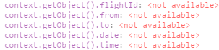

You see that there are currently no values assigned to the context object, because the variable was not yet created. Therefore, execute your program step-by-step by clicking on (or pressing F10) above the watch section four times. Now, the variable was created, and you should see the values of your selected flight object.

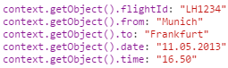

Go on with the program execution by clicking on . Close the development tools by clicking on .

Remark: Although we only traced some single variables in this exercise, you may have probably noticed that the debugger is a powerful tool to find errors. For example, if a text field does not show the right value, you can always trace how a variable value changed, and why it probably shows the wrong value. By adding values to the watch section, you can simulate program executions, and find out e.g. how you have to change your code. Furthermore, strong errors such as syntax errors are directly shown in the console. Therefore, always make use of the debugger if you want to find out more details about your program logic.

Challenge: Implement the Departure tab of your SAPUI5 application
Task 1: Implement the departure tab, similar to how it was done for the arrival tab. Create a new JSON file, in which you change the plannedArrival attribute to plannedDeparture. Then, manipulate the main view to show a table in the departure tab with this flight data, having the same columns as in the arrival tab. You also have to load the new JSON model in the onInit function. Afterwards, create a new detail view called departure for departing flights, containing the plannedDeparture field instead of plannedArrival. Finally, implement the press event and a back button using the departure view and its controller. Submit your changes to the SAP backend.

Task 2: Debug your application using a breakpoint in the onBeforeShow function, which is called within the onInit function of your new departure controller. Investigate the evt.data.ctx variable by displaying if the right flight data is stored therein. For this, add the variable to the watch section and modify its expression accordingly to show the single flight attributes (cf. task 6 of the exercise).

